Overdale Community Primary School – Nursery Autumn Term 2 2022
Theme: Celebrations?
Specific Area: Literacy  Talk for writing texts – Little Red Hen, Baking bread  Focus texts- We’re going on a Bear Hunt, Brown Bear  This half-term we will be beginning our Little Wandle ‘Foundations for Phonics’ programme. In this programme, we will be focusing on the sounds of our language to prepare the children for their formal phonics teaching in reception. We will be sending materials home for you to support you child at home. We will also be holding a phonics evening for parents where we will be explaining the rationale behind our phonics teaching and demonstrating what this looks like in a practical way.  We are continuing to support the children with their name recognition as well as providing opportunities for them to practise ordering the letters in their name. We are also practising name writing weekly for those children who are ready to do so.  We will be using Talk for Writing to develop our story telling and to create our own stories.  We will also be learning and exploring a variety of nursery rhymes and stories focusing on specific vocabulary to support the children’s developing speech and understanding- We will be sharing these on Class Dojo each week |  | 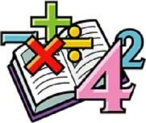  Specific Area: Mathematics  Number  We will be learning a variety of counting nursery rhymes which we will share on class Dojo each week.  We will also be exploring the numbers 1 by learning to subitise 1 (say the amount without having to count) and recognise the numeral one.  We will be investigating the names and properties of common 2D and 3D shapes and exploring how they are similar and different  We will also be exploring repeated patterns and learning how to extend a simple pattern e.g. red, blue, red, blue …  We will also be doing lots of learning around comparison- comparing 2 groups of objetcs which are not the same- e.g. 3 bananas and three apples- ‘How are these groups different?’  Support us at home by discussing these concepts in practical ways.  We will be sending home regular information sheets to explain how you can support us with these concepts at home
Specific Area: Knowledge and Understanding of the World  Our Key question is ‘Which times are special and why?  We will be investigating a variety of festivals and celebrations which happen at this time of year across the world including: Bonfire night, thanks giving, Remembrance, Advent and Christmas  We will also be exploring Autumn and the changes which happen at this time. The children will be making their own winter habitats for various animals to keep them warm and dry over the winter.  We will continue to practise using an iPad to take photographs and to open QR codes to read books and access educational apps | Celebrations  BIG QUESTION  How do we celebrate at home? |  | Specific Area: Personal and Social Development (PSED)  Each half-term we focus on an aspect of our school values. This half-term we will be exploring ‘Respect’  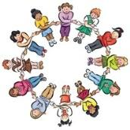  We will take part in circle time activities which look at: Respecting ourselves- our own feelings and needs, making friends- considering the needs of others and respecting our class and home environments.
Specific Area: Physical Development  The children will be developing their finger strength and fine motor skills by taking part in weekly doh-disco activities. We will also be providing them with opportunities to practise their tripod grip to prepare them for writing.  Outside the children will be practising the gross motor skills by taking part in activities involving dancing, jumping, running and skipping. | Prime Area: Communication and  Language  The children will be very familiar with our concept cat now, who supports us to learn key concept vocabulary. The children will be introduced to a key word each week which we will explore in a variety of concepts. These will also be shared on class Dojo with activities to support with at home.  There will also be a nursery rhyme which we focus on each week. |  | Specific Area: Expressive Arts and Design Music  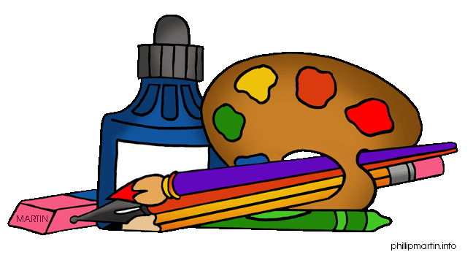  This half term will be when we learn songs and how to perform in our nativity.  We will also be exploring joining techniques in the workshop, where the children will learn a variety of ways to join materials. We will be creating bonfire night rockets, collages, split pin animals and wrapping presents in Santa’s workshop.

Reading – We will be sending children home with a story from our ‘borrow box’ this half-term. We want foster a love of reading in our children so they will be selecting their own book to bring home and share with you. Please read and discuss this with your child at home and write a comment in your child’s reading record. We would like you to share any story with your child at least 3 times a week and record this in their reading record each time. Books will be changed once a week, but your child’s book bag needs to be in school every day please – thank you for your support
Dojo profiles – Please remember to send us photos and videos of what your child is doing at home – anything from walking the dog, swimming, playing in the play park, baking etc – we can’t wait to see your photos

